# CS 255 System Design Document Template

This template lays out all the different sections that you need to complete for Project Two. Each section has guidance to prompt your thinking. You will need to continually reference the interview transcript as you work to make sure that you are addressing your client’s needs. There is no required length for the final document. Instead the goal is to complete each section based on what your client’s needs are. Remove this note when you are finished, and replace all bracketed text with the relevant information.

## UML Diagrams

### UML Use Case Diagram

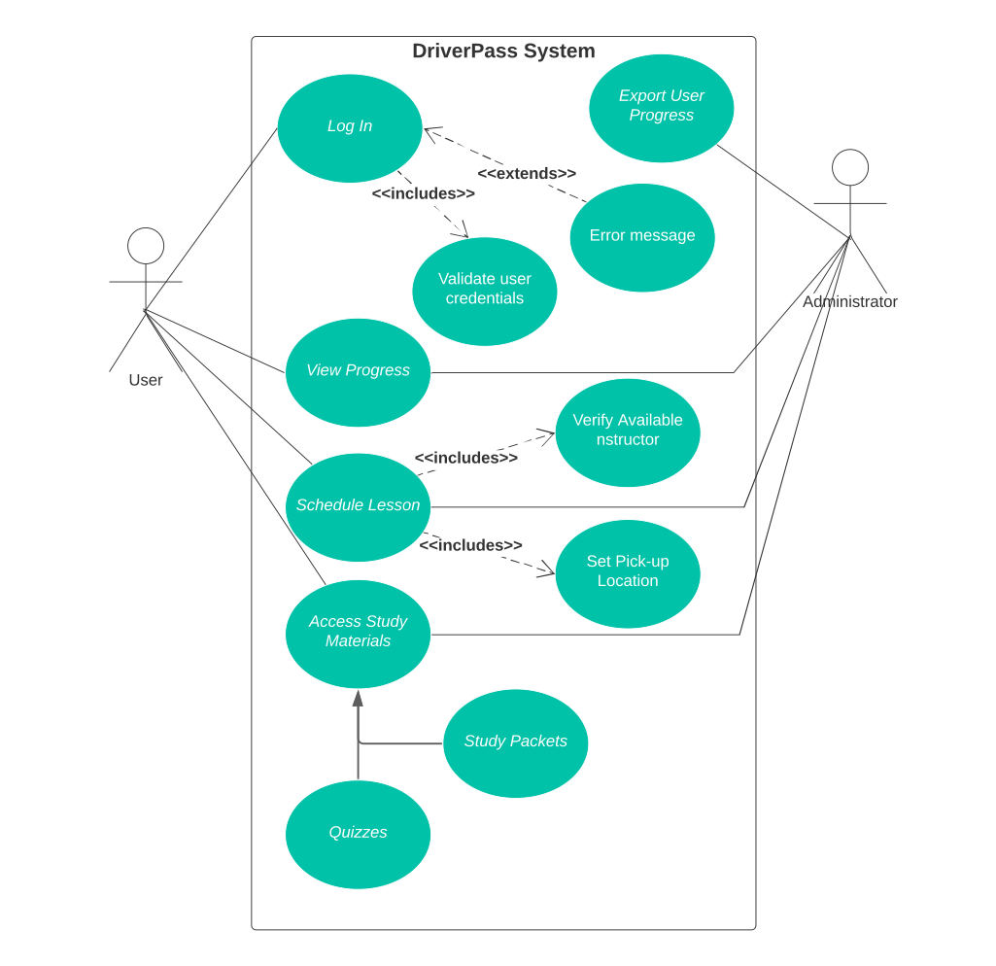

### UML Activity Diagrams

* UML Activity diagram for a student user scheduling an in person driving lesson within the DriverPass system*. 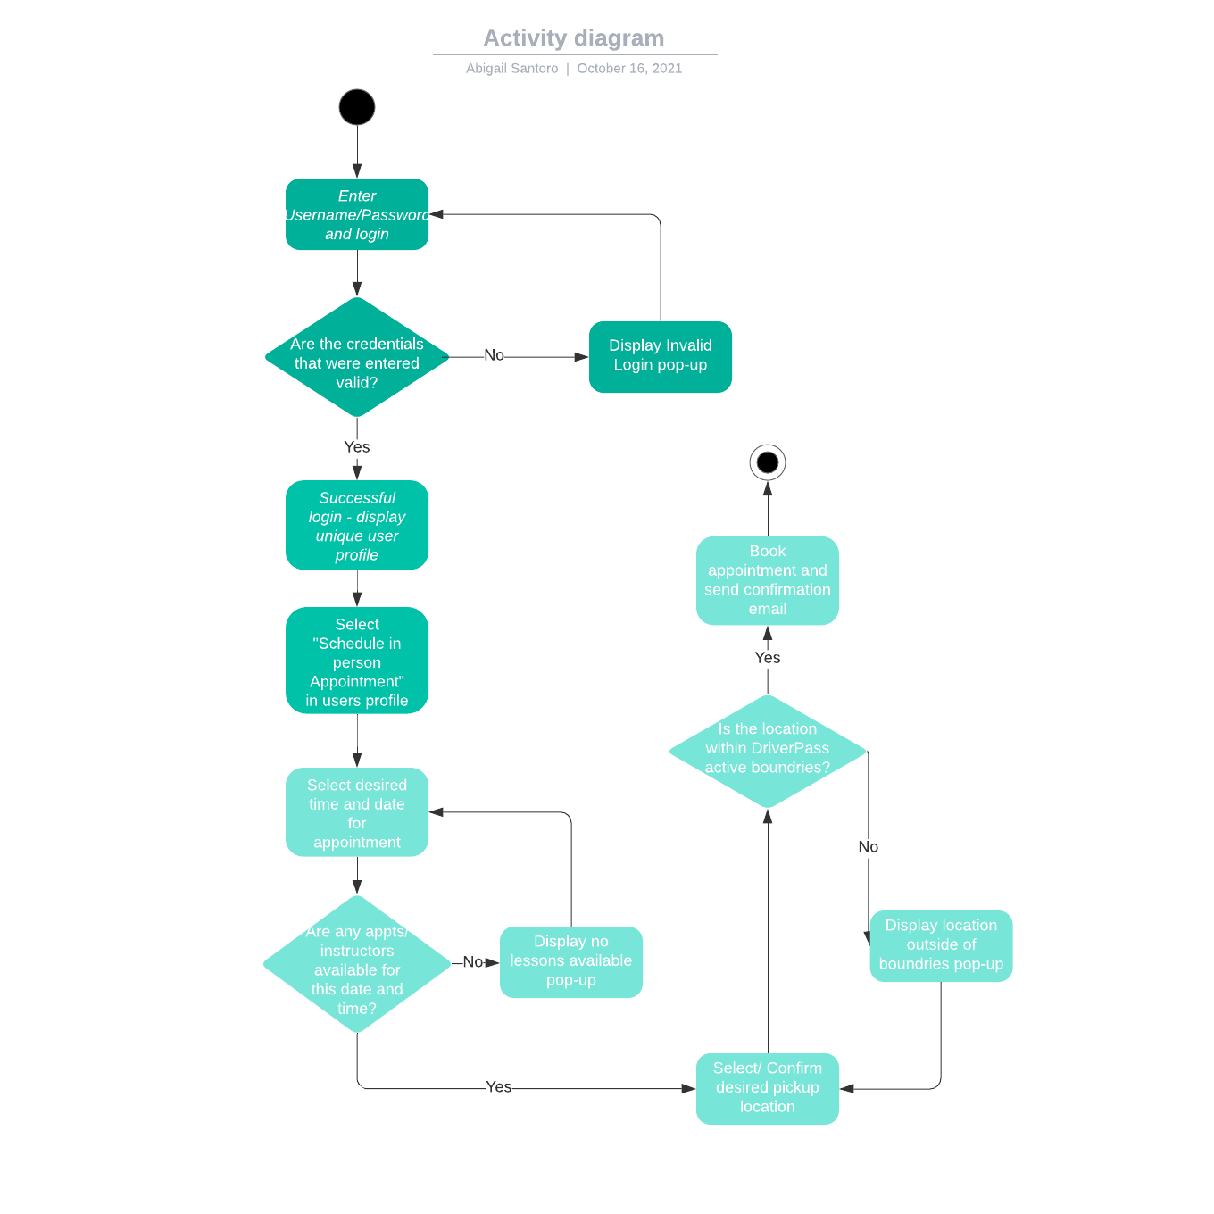*
* 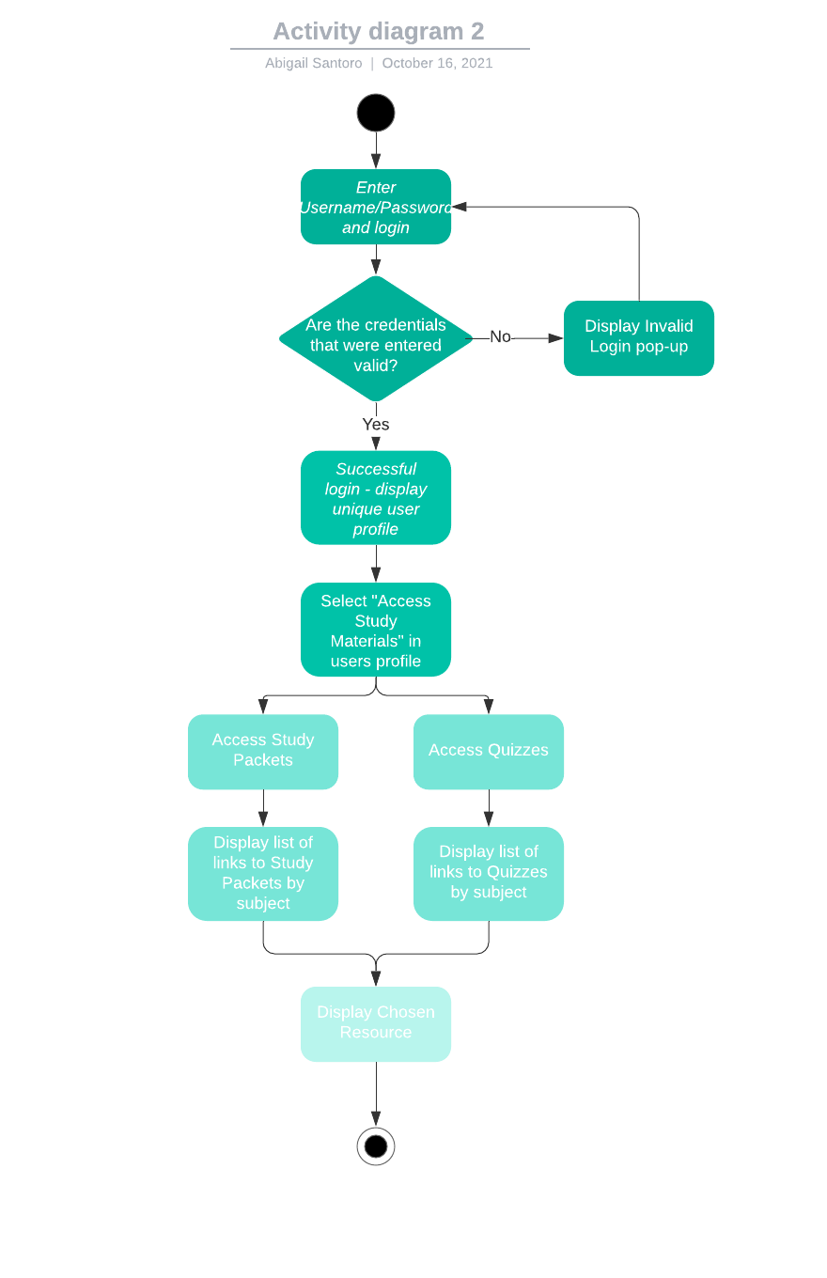UML Activity diagram for a student user accessing online study materials within the DriverPass system.

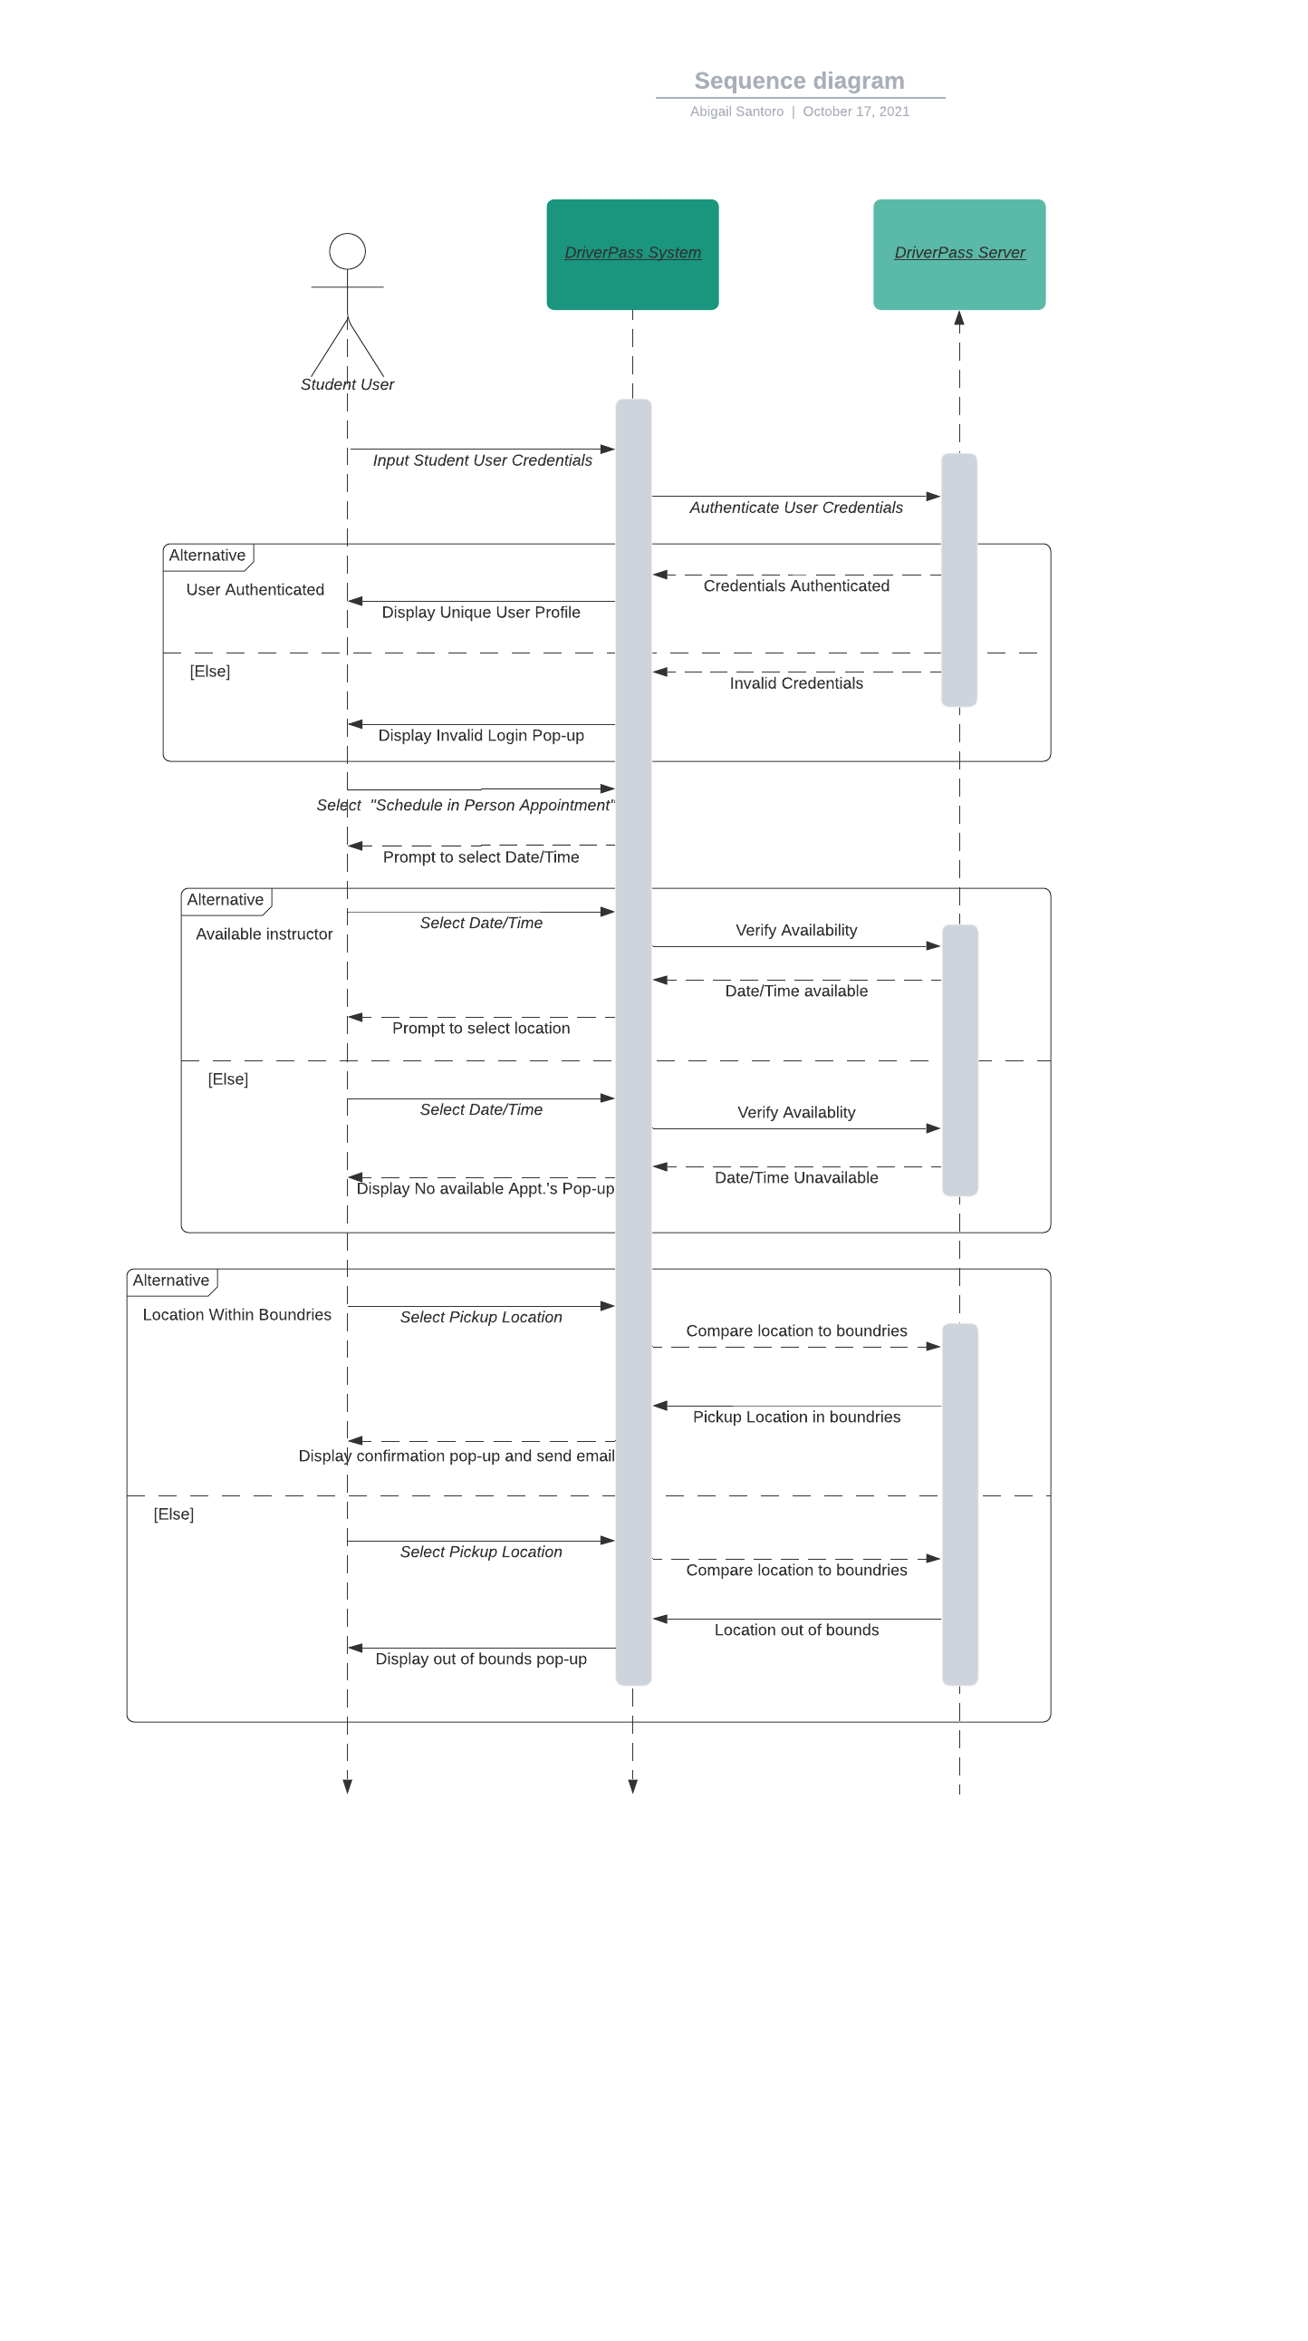

### UML Sequence Diagram

### UML Class Diagram

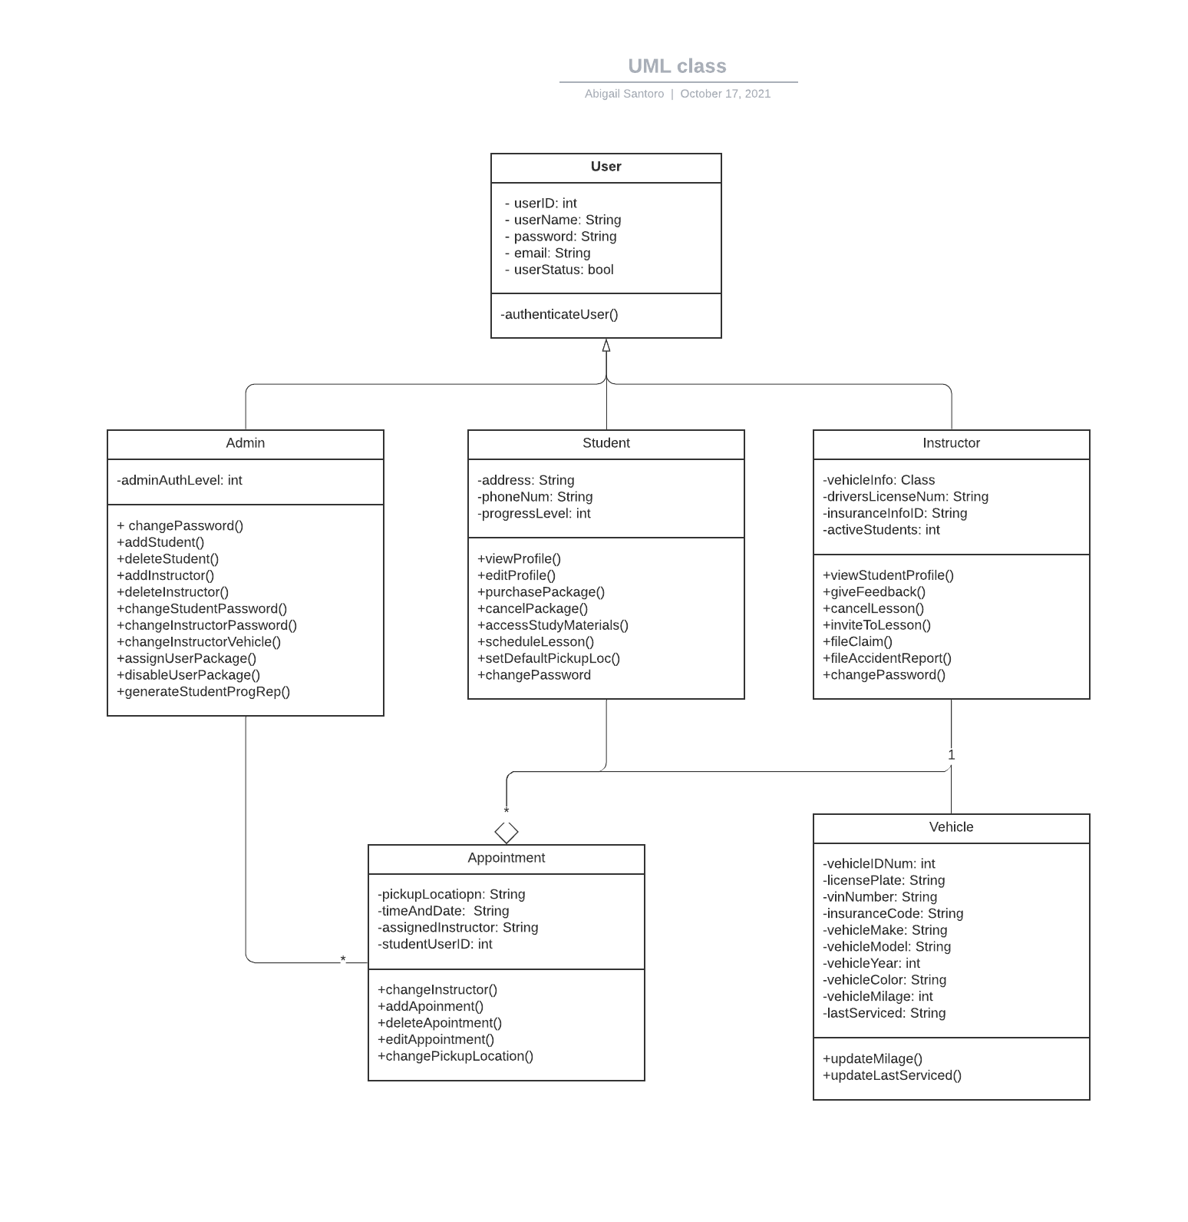

## Technical Requirements

* The system will use two-factor authentication at the time of log in, so that the system will give users proper data authorization based off of who they are authorized as.
* The system will provide a unique user profile displaying their progress, opportunities to improve, instructor comments, links to online study material as well as tests and quizzes.
* The system will provide the user with the ability to select and pay for packages that provide DriverPass services at value, as well as the ability to schedule and pay for an in person driving lesson.
* The system should allow for users to add a pickup/dropoff point for in person driving lessons as well as provide the user with information about the specific car and a photo of the instructor they will be working with.
* System must have special admin. accessibility and be able to authenticate administrators during time of login.
* System will notify users about any upcoming in person appointments, progress updates, and comments posted by their selected instructor, and notify instructors about any upcoming appointments or feedback that is due.
* System will allow for the upload/ download of files by users and administrators.
* The system will access and display accurate and current progress information based on user/instructor login information.